Mode Solution in Arbitrary Slab Waveguide using Finite Difference Approach

(This should be transferable to a solution in an arbitrary quantum well).

Justification:

For a number of years I have been calculating the solution to an arbitrary 2D waveguide, or quantum well structure using a matrix method. This is prone to errors that can be seen as the field decays. In general this is not a problem, since it appears when the field is at least 6 orders of magnitude below the peak value (usually 12-15 orders of magnitude). Unfortunately, when using the BPM these low values of incorrect values lead to problems at the boundary condition. Since it is possible to calculate the guided mode using the FD approximation, this may be a useful solution.

Finite Difference (FD) Approximation

The Finite Difference (FD) approximation can be evaluated for quasi-TE and quasi-TM, or for a scalar solution. To begin with, we will assume the scalar solution.

The equation that needs to be solved is:
TE: 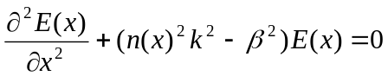 (1a)
TM: 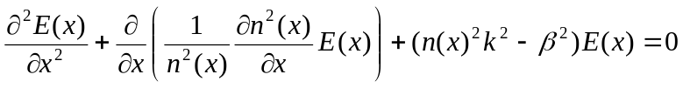 (1b)
We want to discretise along the direction of our calculation, by breaking up the region of the calculation into N different pieces each separated by Δx. We then describe the electric field as:
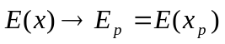, where 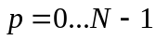 (since I program in C++)
Here:
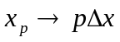
Using a Taylor’s Series expansion, we can say:
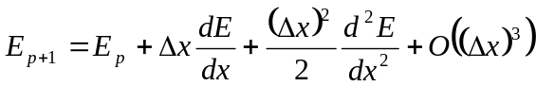, and (2)
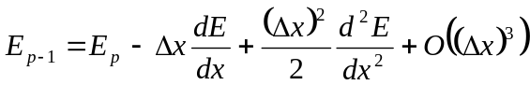 (3)
Adding these two equations yields the following approximate equation (ignoring higher order terms):
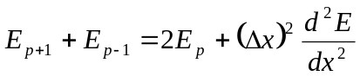, and therefore:
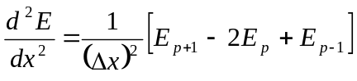 (4)
We can now rewrite equation (1) using this approximate solution, namely:
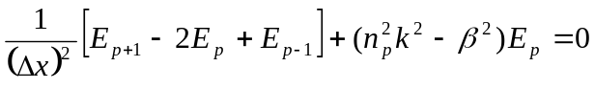
Alternatively this can be written as:
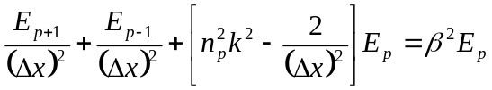 (5)
Here our eigenvector is the electric field profile, and the eigenvalue is β.

For a more physical solution to the eigenvector, we note that:
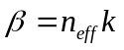, thus we re-write equation (5) as:
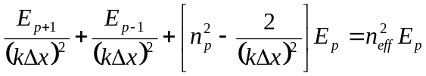
For 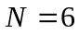, this would look like:
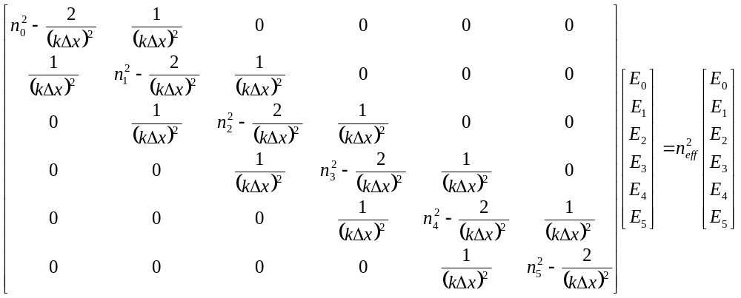
Here we have a problem at the boundary which we have neglected.

Boundary Conditions

There are 3 types of boundary conditions that are typically employed: the Dirichlet, the Neumann and the Analytical boundary condition, they are:

Dirichlet
Outside the analysis region:
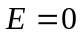, that is the electric field is zero at the boundary.

Neumann
Outside the analysis region:
, that is the electric field at the boundary is the same as that outside.

Analytical
At the boundary, the mode is assumed to continue to decrease exponentially:
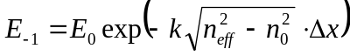

These boundary conditions can be summarized as:
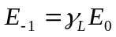, where
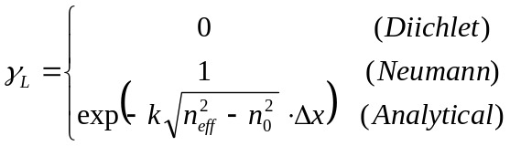
And:
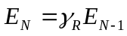, where
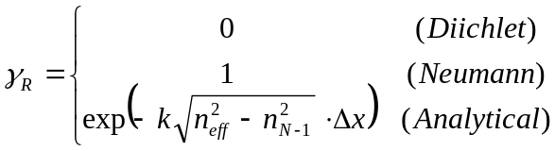

To apply the boundary condition we look at both boundaries

Our equation at the left boundary is:
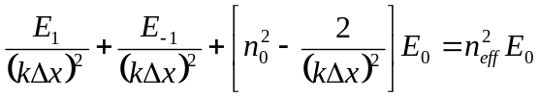
From the boundary condition, we then write:
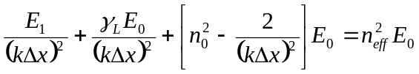, and finally:
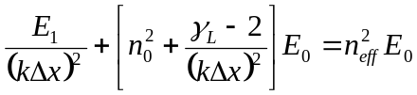 (6)

Similarly for the right boundary, we could write:
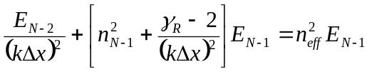 (7)

Using these boundary conditions the matrix equation now becomes:
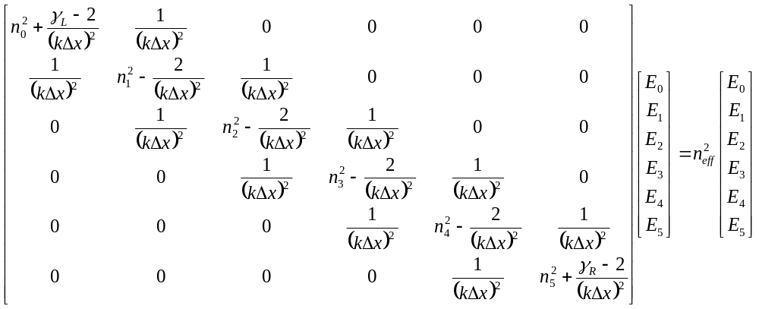
There are a number of good linear algebra algorithms for solving this matrix equation. I plan to use LU decomposition, because it is available. For ease of coding, the matrix is visualised as:
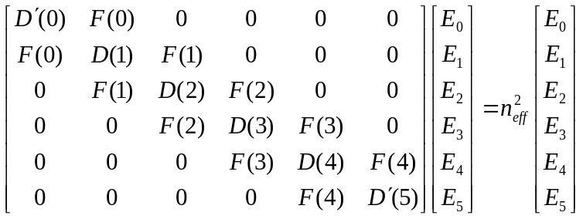

Then we fill the vectors as:
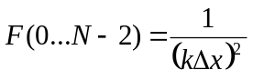 (for ofF diagonal)
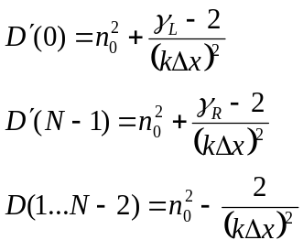 (for Diagonal)

Additional notes on Boundary Conditions

For the Dirichlet and Neumann boundary conditions, the solution is straight forward. For the Analytical boundary condition, it is not. This is because the boundary condition assumes the value of the eigenvalue:
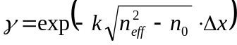
Thus the eigenvalue 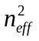can be initially set or assumed to be 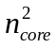 and then adjusted following the initial solution. This means that for the analytical boundary condition the solution cannot be calculated in a single step. Depending on the convergence of the problem, standard numerical methods may need to be employed to accelerate the calculation time for full convergence.

Coding

Using C++ it is my preference to use <vectors> in order to hold values. Thus to begin with the index distribution:
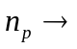 vector <double> Index;
This would be populated in a standard way, and the size is given by:
int N = Index.size();

Based on the index distribution, we would also know the maximum and minimum index values:
double nmax, nmin;
// first find the maximum and minimum index
nmax=-1E17;
nmin=1E17;
for (i=0;i<N;i++) {
if (Index[i]>nmax) nmax=Index[i];
if (Index[i]<nmin) nmin=Index[i];
}

Then we would calculate using (initially) the maximum index value.
double gL,gR; // that is gamma
// calculate gamma for the boundary condition
gL = exp(-k*sqrt(nmax*nmax-Index[0]*Index[0])*dx);
gR = exp(-k*sqrt(nmax*nmax-Index[N-1]*Index[N-1])*dx);

At this point we can populate the diagonal and off-diagonal elements.
vector<double> diag, off_diag;
diag.resize(N);

// first the diagonal elements
diag[0] = Index[0]*Index[0] + (2.0-gL)/(k*dx)/(k*dx);
for (i=1;i<N-1;i++) {
diag[i] = Index[i]*Index[i] - gL/(k*dx)/(k*dx);
}
diag[N-1] = Index[N-1]*Index[N-1] + (2.0-gR)/(k*dx)/(k*dx);

off_diag.resize(N);
// the the off diagonal elements
off_diag[0]=0.0;
for (i=1;i<N;i++) {
off_diag[i] = 1.0/(k*dx)/(k*dx);
}

The modified QL solver for the eigenvalues and eigenvectors requires an identity matrix as an input. The eigenvectors will then be returned within this matrix. Therefore it needs to be specified
vector< vector<double> > Field;
Field.resize(N);
for (i=0;i<N;i++) {
Field[i].resize(N);
for (j=0;j<N;j++) {
Field[i][j]=0.0;
}
Field[i][i]=1.0;
}

